**Hydrogen Industry in North America**

**Report Outline**

1. **Market Overview** (Christine, Leo, Sozy)
   1. Growth trend regionally and globally
   2. Importance of hydrogen in the energy landscape
   3. Key players and stakeholders
2. **Policy Landscape** (Cindy)
3. **Hydrogen Production**
   1. Different production methods, pros and cons (Jason)
   2. Environmental impact of analysis of each methods (Jason)
4. **Storage and Transportation**
   1. Different Methods, pros and cons (Sozy)
5. **Utilization** (Cindy)
   1. Different end uses: industry, transport, buildings, power generation
6. **Investment Opportunities** (Leo)
   1. Key investment opportunities within hydrogen sector
   2. Investment trends
7. **Risk Assessment** (Mengle)
   1. Regulatory, technology, supply chain risks etc.
8. **Financing Methods (Leo)**
   1. Bonds, project finance, tax equity
9. **Recommendations and conclusion**

**Feedback (11/22): 不同上下游阶段，注意一下，每个选代表性的公司。多所以不要太散，到时候ppt的内容过一下。**

# 1. Market Overview

#### Emerging green hydrogen market to redraw the global energy and resource map as early as 2030, creating a $1.4 trillion a year market by 2050.

1.1 Growth trend regionally and globally

The hydrogen industry in North America, as well as globally, is showing a clear growth trend.

1. Momentum in Hydrogen Project Pipeline:

The Hydrogen Council, in collaboration with McKinsey & Company, presents the "Hydrogen Insights 2023" report, offering a comprehensive overview of the global hydrogen sector. It highlights that more than 1,000 hydrogen projects requiring investment of around USD 320 billion have been announced worldwide. However, only 10% of these projects have passed the Final Investment Decision (FID) stage. North America, along with Europe, accounts for nearly 60% of the announced clean hydrogen production, with a total of 38 million tonnes per annum (Mt p.a.) expected through 2030. Currently, about 0.8 Mt p.a. of clean hydrogen supply is operational, with North America contributing a significant portion of the operational low-carbon capacity. This represents a major momentum in the hydrogen project pipeline across all stages of maturity, indicating a healthy project funnel. (Source: <https://hydrogencouncil.com/en/hydrogen-insights-2023/> )

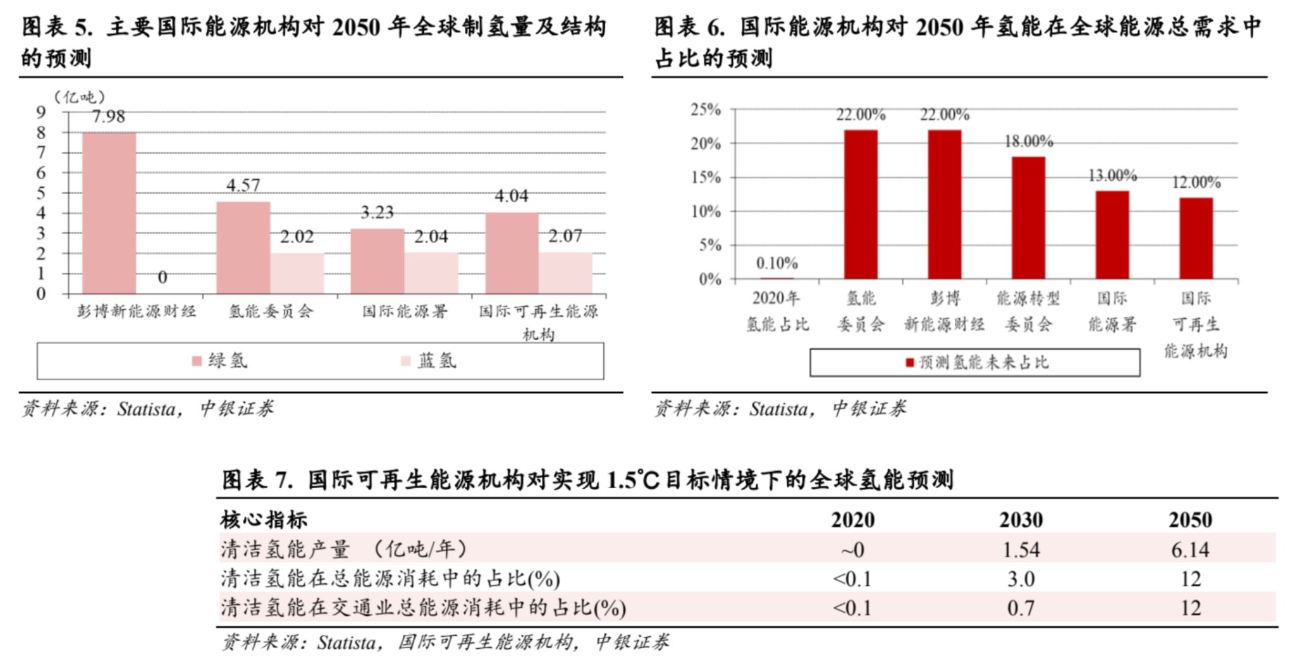

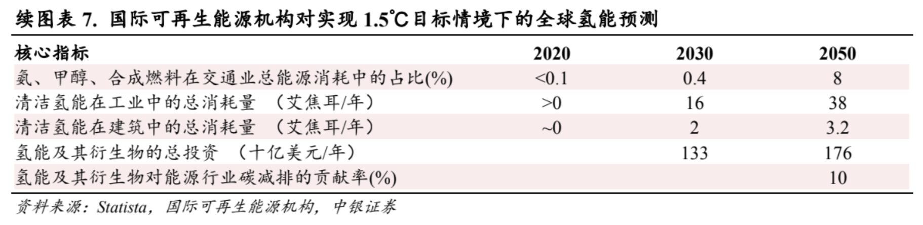

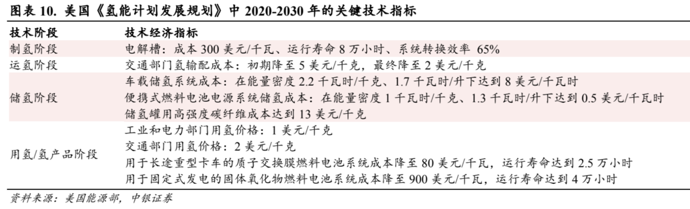

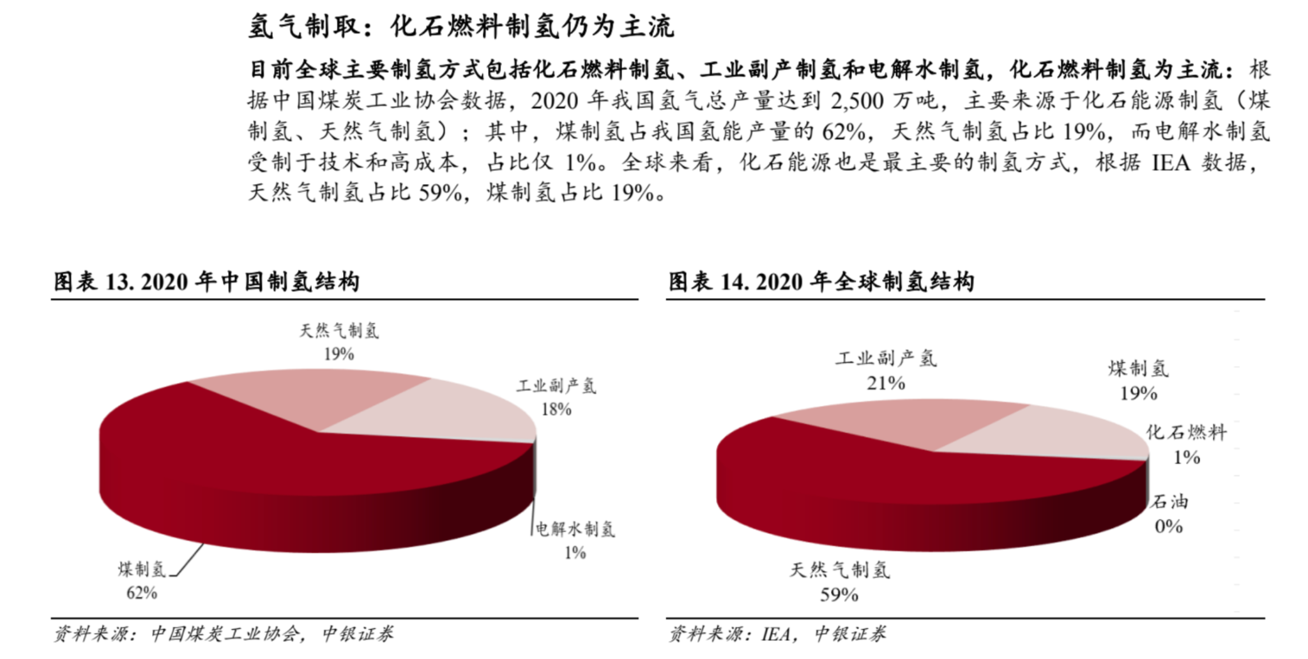

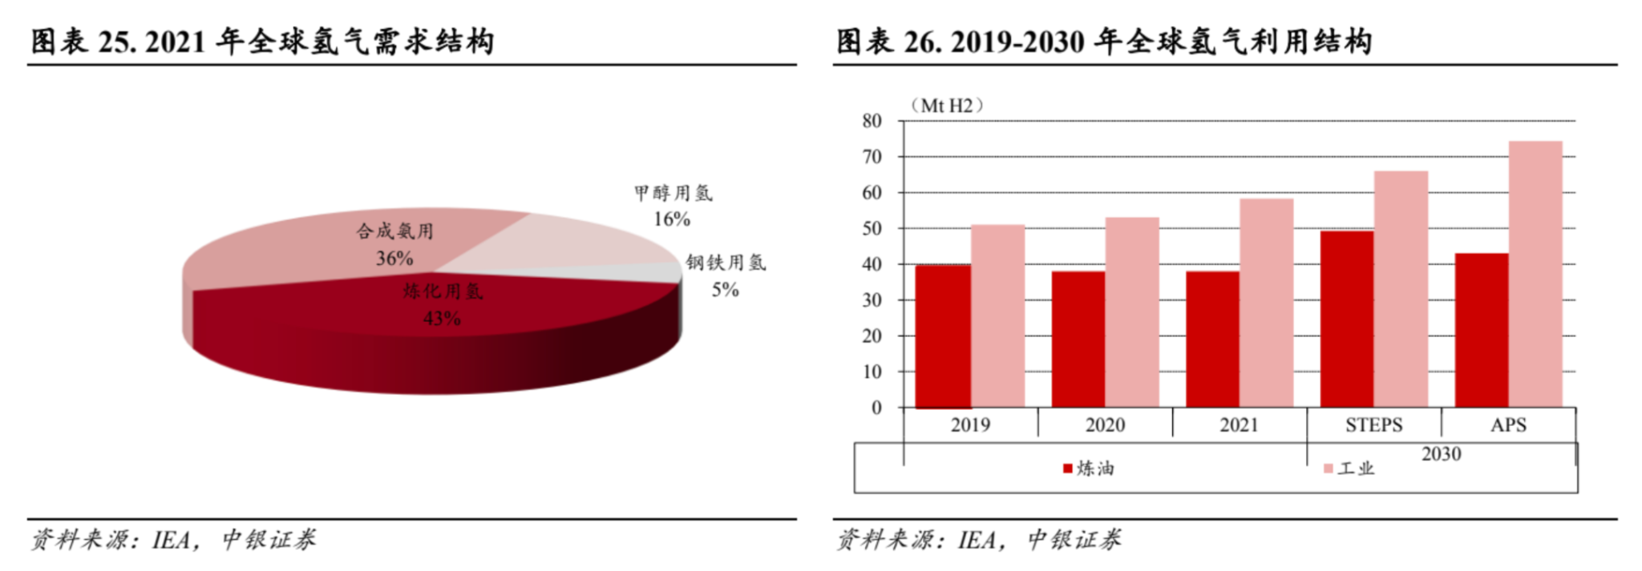

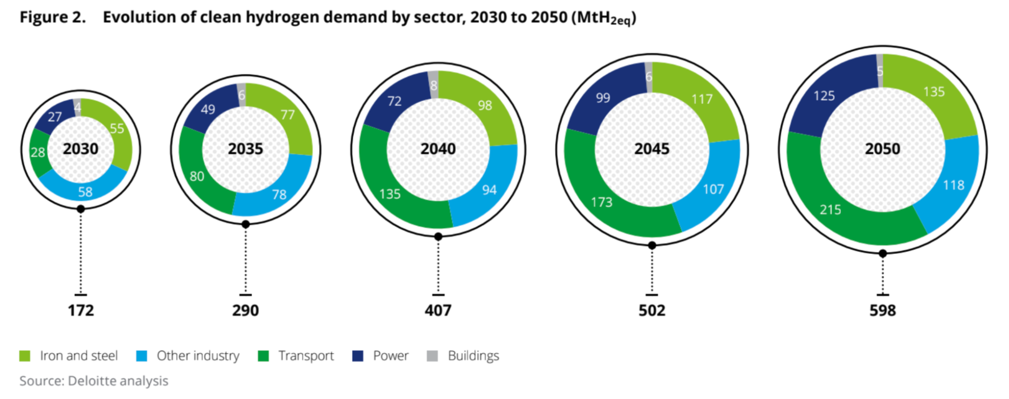

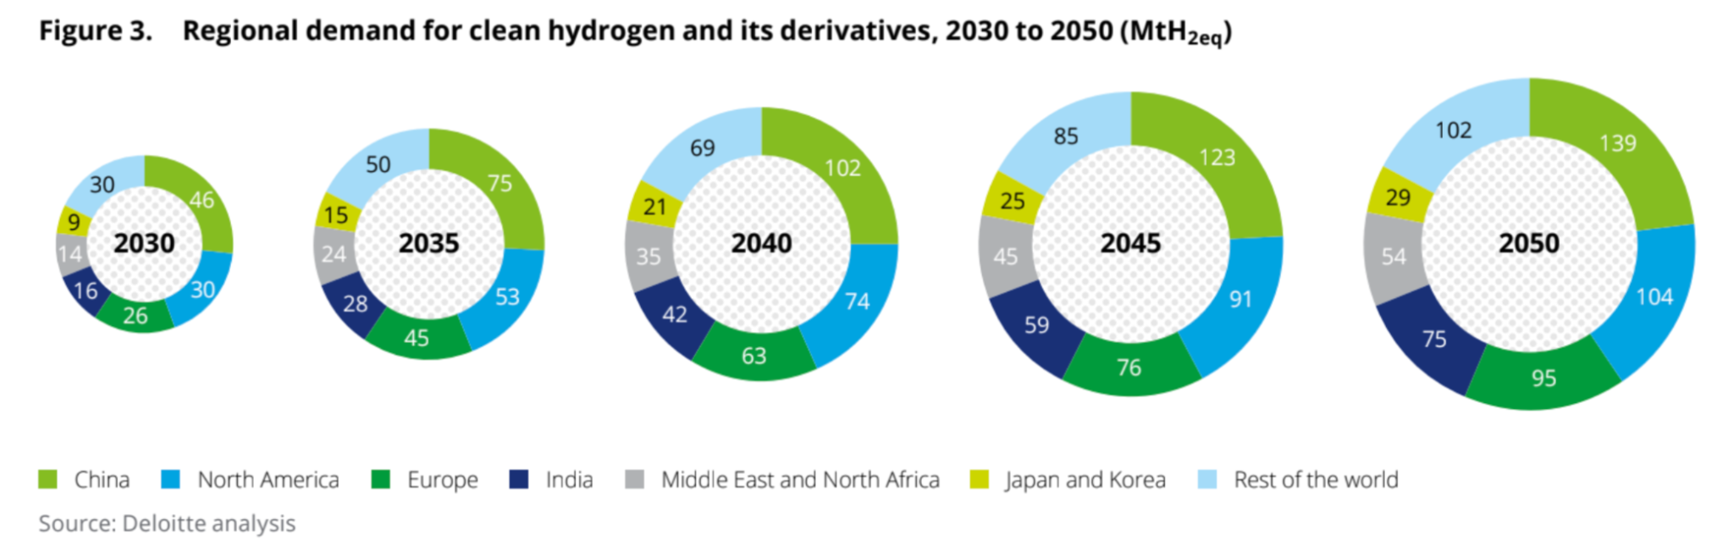

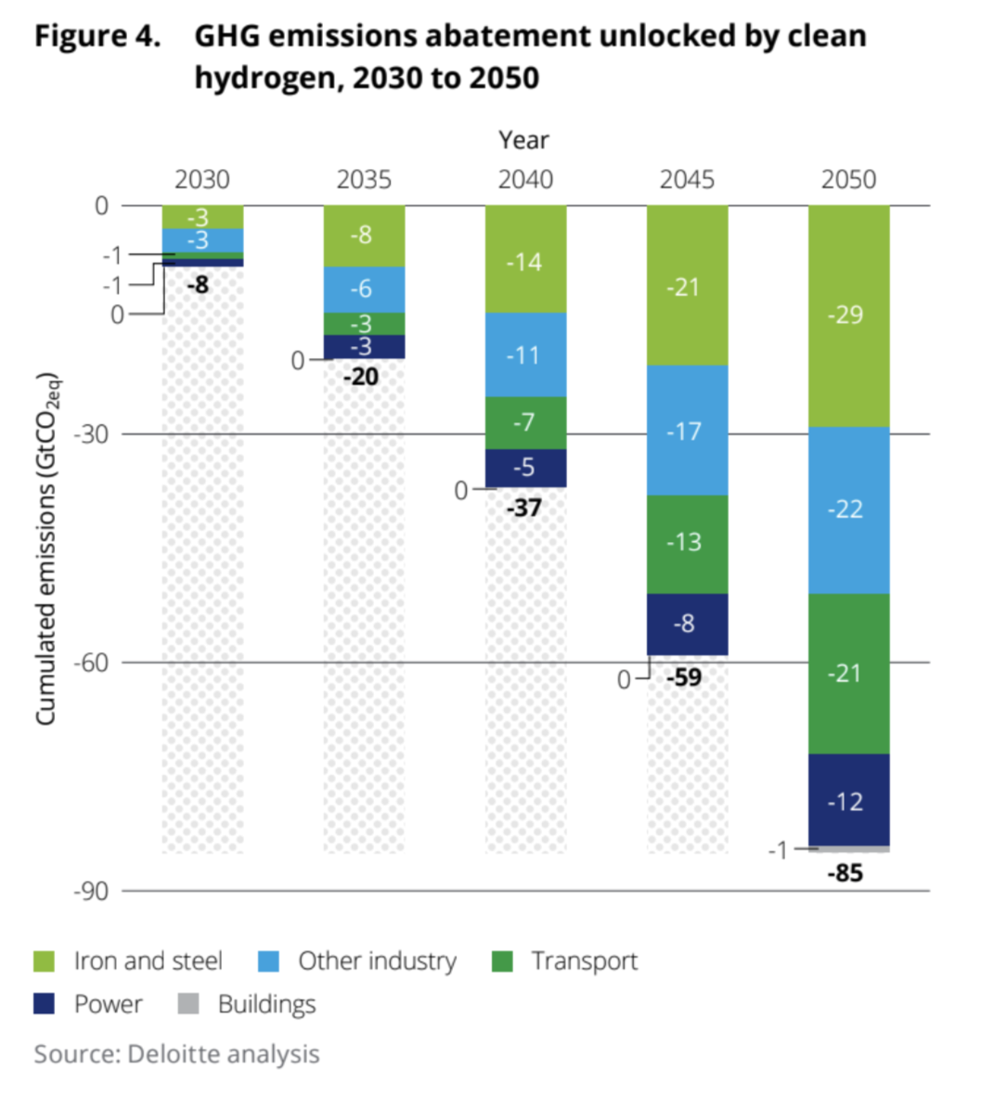

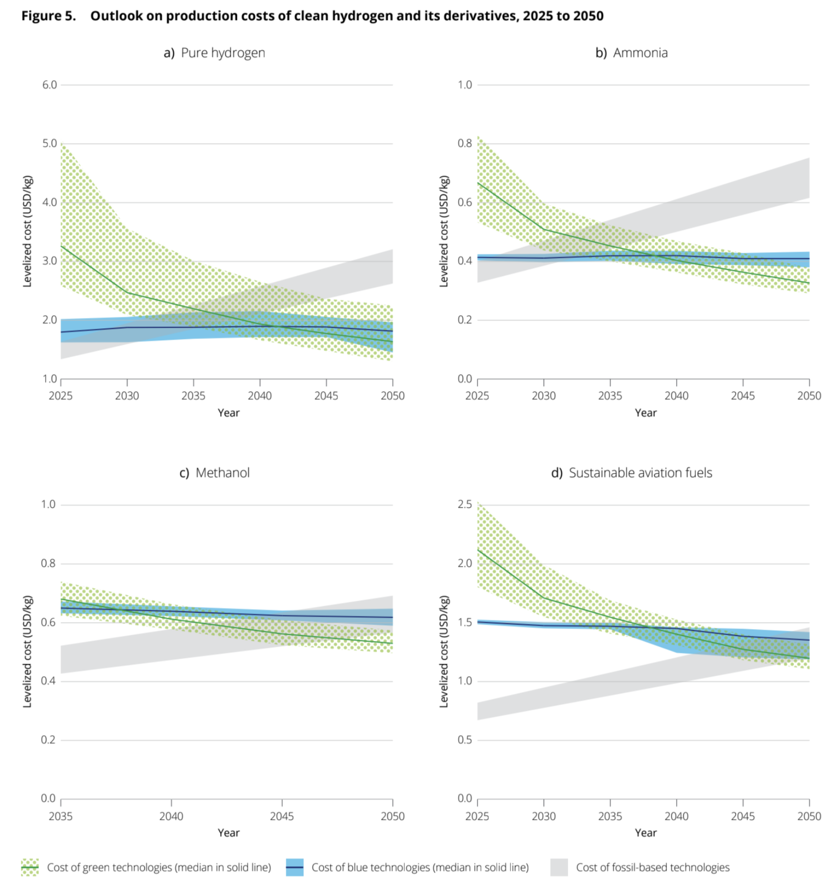

2. Hydrogen Generation Market Projection: (补充数据，graph，hydrogen的应用在每个industry的增长，green/blue/gray hydrogen growth)

Globally, the hydrogen generation market is projected to reach a value of $271.1 billion by 2028, up from $166.7 billion, growing at a Compound Annual Growth Rate (CAGR) of 10.2% during the period from 2023 to 2028. This growth signifies the increasing emphasis on hydrogen as a clean energy source, especially for heavy-duty applications, and aligns with global efforts to meet net-zero emissions goals. (Source: <https://www.globenewswire.com/news-release/2023/11/09/2777068/0/en/Global-Hydrogen-Generation-Industry-Report-2023-A-270-Billion-Market-by-2028-Hydrogen-Becoming-An-Attractive-Fuel-Source-for-Heavy-Duty-Applications-with-Increased-Emphasis-on-Meet.html#:~:text=Global%20Hydrogen%20Generation%20Market%20is,2028> )

Development goals for the clean hydrogen market:

- 170 MtH2eq by 2030

- Nearly 600 MtH2eq by 2050

Demand for hydrogen and its derivatives by 2050:

- Pure hydrogen: Nearly 390 Mt

- Ammonia: More than 590 Mt (104 MtH2eq in hydrogen equivalent)

- Sustainable aviation fuels (SAF): 134 Mt (80 MtH2eq)

- Methanol: 130 Mt (25 MtH2eq)

Sectoral demand for clean hydrogen by 2050:

- Industry (iron, steel, etc.): 250 MtH2eq (42% of total demand)

- Transport: 215 MtH2eq (36% of total demand)

- Power system (for storage and flexibility): 125 MtH2eq (about 20% of total demand)

- Buildings (via natural gas network blending): Marginal at 5 MtH2eq (less than 1% of total demand)

Global market development:

- Clean hydrogen market expected to grow in industrialized economies initially

- Developing countries could benefit from sustainable growth and decarbonization through clean hydrogen

Potential for emission reductions:

- Clean hydrogen could abate up to 85 GtCO2eq by 2050

- The iron and steel industry alone could account for 60% of these reductions despite comprising 42% of hydrogen demand

3. Global Investment lead in hydrogen technology and infrastructure:

Investment in hydrogen technology and infrastructure is strong across various countries. China leads as the largest producer of hydrogen, followed by significant investments from countries like Germany, South Korea, Japan, and the United States. This investment is part of a broader push to increase hydrogen production capacity, which is a crucial component in transitioning to a sustainable energy future. (Source: <https://www.globenewswire.com/news-release/2023/11/09/2777068/0/en/Global-Hydrogen-Generation-Industry-Report-2023-A-270-Billion-Market-by-2028-Hydrogen-Becoming-An-Attractive-Fuel-Source-for-Heavy-Duty-Applications-with-Increased-Emphasis-on-Meet.html#:~:text=Global%20Hydrogen%20Generation%20Market%20is,2028> )

The above information reflects a growing recognition of hydrogen as an integral part of the future energy mix, with substantial investments aimed at enhancing production capacity and infrastructure. The focus in North America and globally is on developing a robust hydrogen economy that can contribute to energy sustainability and carbon emission reductions.

<https://www.forbes.com/sites/ianpalmer/2022/09/29/the-surging-hydrogen-economy-that-oil-and-gas-companies-are-tiptoeing-into/?sh=1dfe72636341>

1.2 Importance of hydrogen in the energy landscape

- Hydrogen is considered a promising alternative to fossil fuels, as it can be produced from various renewable sources, such as water electrolysis powered by renewable energy. It can be used in fuel cells to generate electricity with water as the only byproduct, making it a clean energy option.

- It has the potential to play a crucial role in sectors where electrification is challenging, such as heavy industry, long-haul transportation, and energy storage.

Hydrogen is forecasted to significantly impact the global effort to reach net-zero emissions by 2050. As it complements other clean energy technologies, hydrogen could be responsible for more than 20% of annual global emissions reductions. By 2050, clean hydrogen might help abate seven gigatons of CO2 emissions annually, representing around 20% of human-driven emissions, assuming current global-warming trajectories.

This reduction is critical across industries such as steelmaking, petrochemicals, fertilizers, heavy-duty mobility, maritime shipping, and aviation. The demand for clean hydrogen could rise to approximately 660 million metric tons annually by 2050, with a significant increase in planned production for green and blue hydrogen. This growth indicates a potential for hydrogen to become cost-competitive in many applications, with production costs expected to decline over the next decade. (Source: <https://www.mckinsey.com/capabilities/sustainability/our-insights/five-charts-on-hydrogens-role-in-a-net-zero-future> )

1.3 Key players and stakeholders

- Companies: Some key players in the hydrogen industry include Air Products and Chemicals, Linde plc, Plug Power, and Bloom Energy.

- Energy Companies: Major energy companies, such as Shell, BP, and ExxonMobil, have also been investing in hydrogen technologies and projects.

- Governments and Regulatory Bodies: Government support through policies, subsidies, and regulations has been instrumental in fostering the growth of the hydrogen industry.

- Research Institutions and Academia: Research institutions and universities play a vital role in advancing hydrogen-related technologies and conducting research on its various applications.

- Investors and Financial Institutions: Investors and financial institutions are providing the necessary funding for hydrogen projects and initiatives, further driving the industry's growth.

**Key global players in hydrogen generation**: Linde Plc, Air Liquide, Cummins Inc., Uniper SE, Nel ASA, Siemens, Engine, ITM Power, Iberdrola, McPhy Energy S.A, Messer, Orsted A/S, Thyssenkrupp, Iwatani Corporation, Xebec Adsorption Inc., Ally Hi-Tech Co. Ltd, and Electrochaea GmbH.

**Main industry involved**: The versatility of hydrogen fuel creates many opportunities to replace fossil fuels in different parts of our economy. It can provide long-term [energy storage](https://climate.mit.edu/explainers/energy-storage) for the electric power sector, fuel for heavy duty transportation, and heat for industrial processes requiring high temperatures, like [steel](https://climate.mit.edu/explainers/mining-and-metals) or [concrete](https://climate.mit.edu/explainers/concrete) production. Today, hydrogen is mainly used in the petrochemical food processing, and fertilizer industries, and in cars with hydrogen fuel cells. Countries such as Japan are exploring its use in public transportation.

About hydrogen and its role in the green energy transition

Currently 80 million tons of hydrogen are produced each year and production is expected to increase by about 20 million tons by 2030. Just 1% of that hydrogen is currently generated from green energy sources. The bulk is obtained from natural gas and coal, emitting 830 million tons of CO2 per year, more than the entire nation of Germany or the global shipping industry. Replacing this current polluting consumption would require 820 GW of wind generating capacity, 26% more than the current global installed wind capacity. Looking further ahead, many studies suggest that by 2050 production will have grown to about 500 million tons with a significant shift to green hydrogen. The expected growth will require between 1,000 GW and 4,000 GW of renewable capacity by 2050 to meet demand, which highlights the vast potential for growth in wind power.

https://www.siemensgamesa.com/en-int/-/media/siemensgamesa/downloads/en/newsroom/2021/01/siemens-gamesa-press-release-agreement-siemens-energy-green-hydrogen-en.pdf

**Industry Overview in Canada(example):**

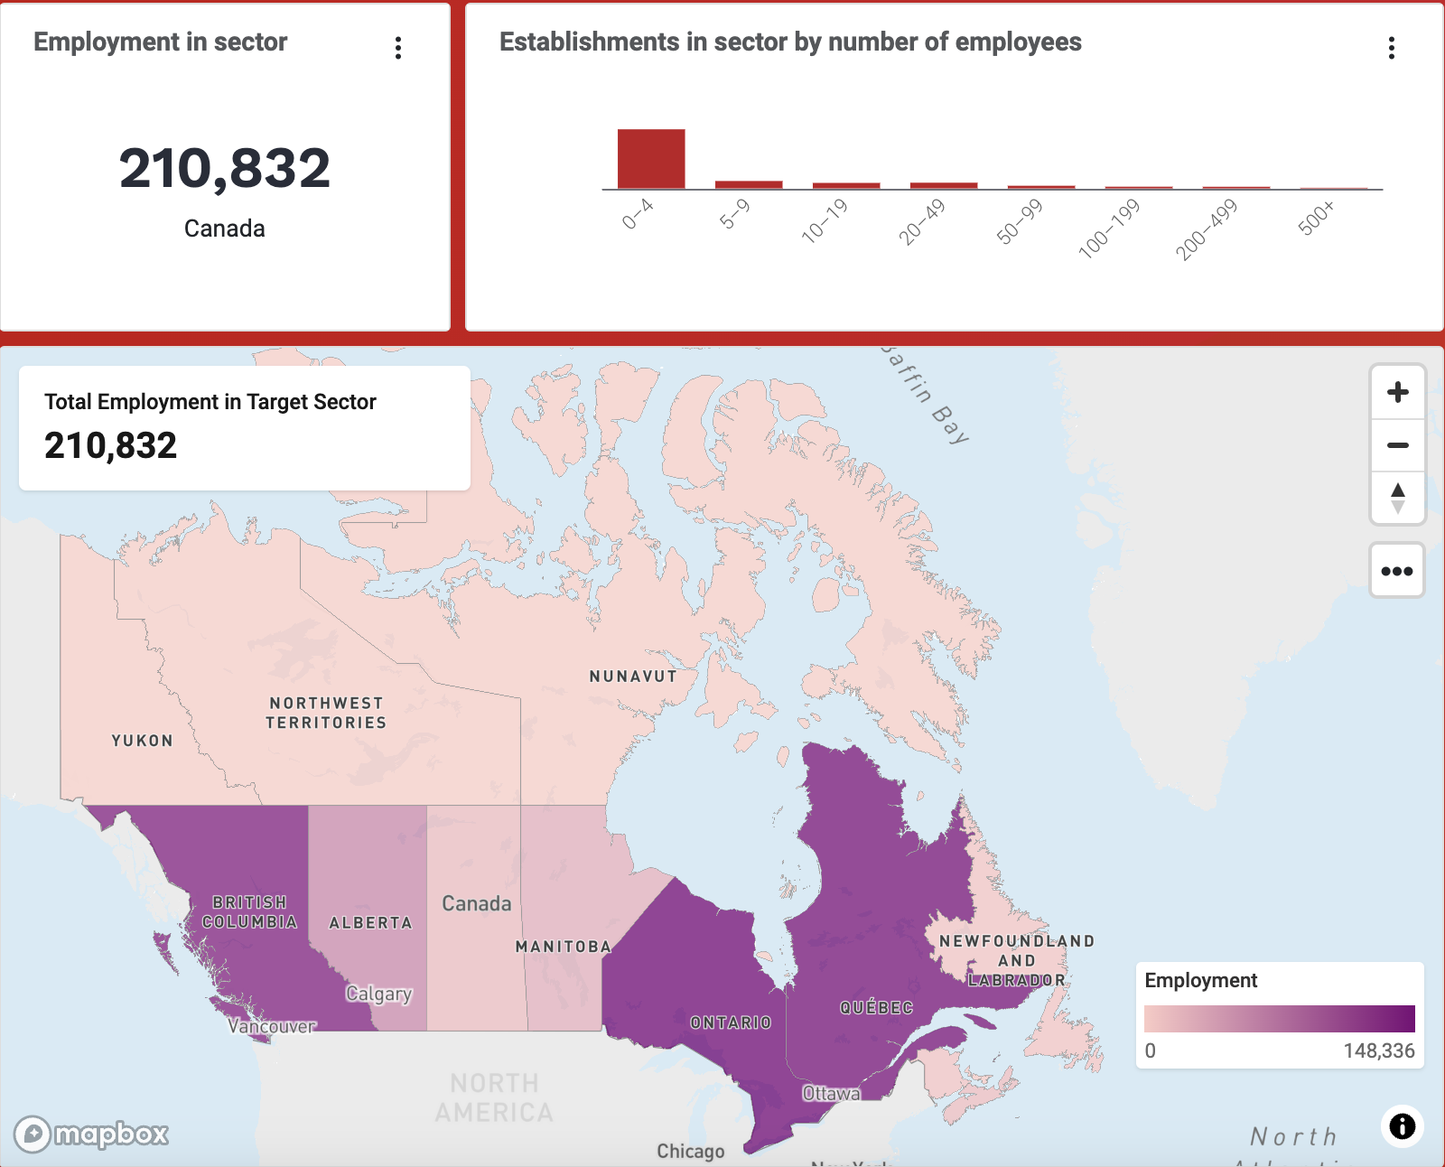

(source: Invest in Canada)

<https://www.investcanada.ca/industries/hydrogen?creative=656688852231&keyword=invest%20in%20hydrogen&matchtype=p&network=g&device=c&gad_source=1&gclid=Cj0KCQiA3uGqBhDdARIsAFeJ5r1eiau6KAbVRw-N3a-uCqqoDMqvUF81-woemLo4hiOzEBfDEV8QHRMaAiSqEALw_wcB>

# 2. Policy Landscape

The Biden Administration passed two laws: BIL and IRA. Because almost all hydrogen today is carbon intensive, BIL and IRA incentives are specifically designed to deploy hydrogen that is produced with few or zero emissions.

**Inflation Reduction Act (IRA)**: the largest investment in clean energy and climate action ever.

* Subsidies up to $3/kg of production tax credit (PTC) by carbon intensity ($/kg), for hydrogen with emissions under 4 kg CO2/kg H2
* Producers can qualify for low-carbon hydrogen and renewable energy tax credits (a PTC of up to 2.6 cents/kWh) simultaneously
* Producers generating hydrogen via conventional methods with CCUS can also qualify for 45Q tax credits ($85/ton of CO2 permanently stored)

**Bipartisan Infrastructure Law (BIL)**

* Passed in late 2021
* Allocates $9.5 billion in direct grant programs for hydrogen production and infrastructure: $7 billion to establishing [H2Hubs](https://www.energy.gov/oced/regional-clean-hydrogen-hubs-0), $1 billion toward strengthening the demand for clean hydrogen, and $1.5 billion towards advancing electrolysis technologies and improving manufacturing and recycling capabilities for all clean-hydrogen technologies.
* In the [news](https://www.whitecase.com/insight-alert/hydrogen-hub-projects-awarded-7-billion-us-department-energy) in October 2023: 7 hydrogen hubs announced and future outlook
  + Example: [Appalachian Regional Clean Hydrogen Hub](https://www.arch2hub.com)

US Department of Energy (DOE)

1. [National Clean Hydrogen Strategy and Roadmap](https://www.hydrogen.energy.gov/library/roadmaps-vision/clean-hydrogen-strategy-roadmap): serves as the primary guiding document
2. [H2@Scale Initiative](https://www.energy.gov/eere/fuelcells/articles/h2scale-handout#:~:text=H2%40Scale%20initiative.-,H2%40Scale%3A%20Enabling%20affordable%2C%20reliable%2C%20clean%2C,and%20secure%20energy%20across%20sectors.&text=The%20DOE%27s%20H2%40Scale%20Consortium,partnership%20with%20industry%20and%20academia.): includes DOE funded projects and national laboratory-industry co- funded activities to accelerate the early-stage research, development, and demonstration of applicable hydrogen technologies.

Regulatory landscape: Federal and local regulators who may oversee each segment of the hydrogen value chain in the US (Source: National Clean Hydrogen Strategy and Roadmap)

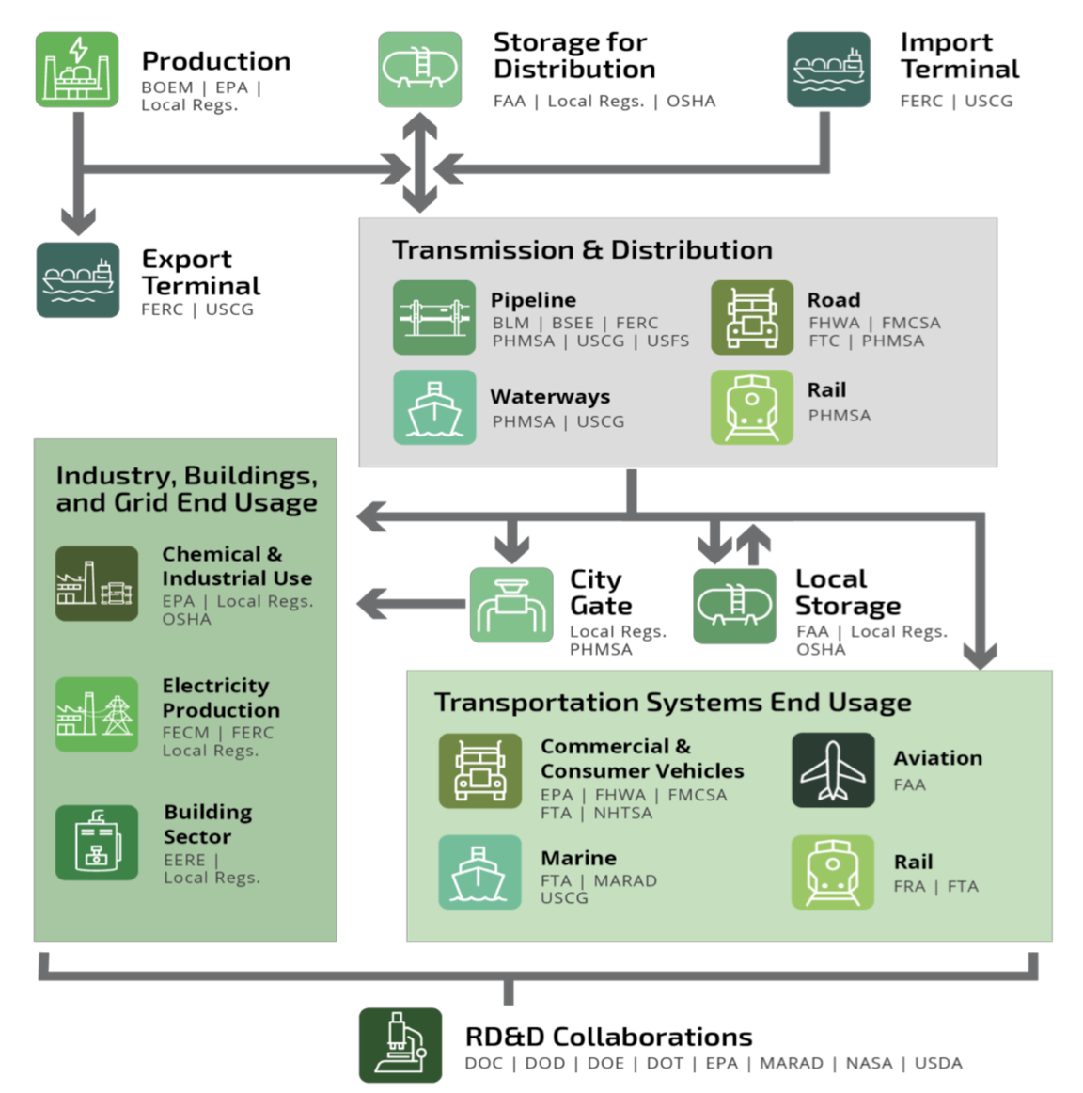

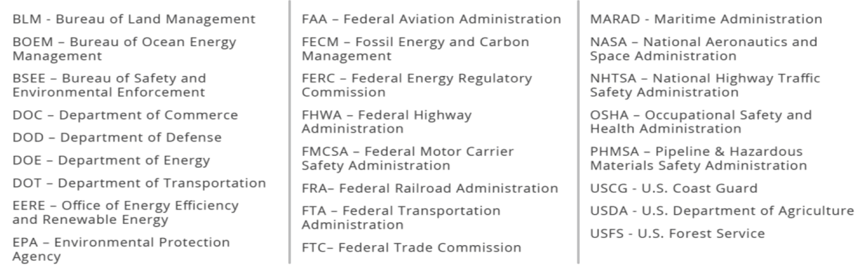

# 3. Hydrogen Production

**3.1 Different production methods, pros and cons**

Link: Low Carbon Hydrogen: Examining decarbonization potential and commercialization pathways through 2035

The upstream segment involves the production of hydrogen, which can be obtained from various sources such as natural gas through reforming and water through electrolysis.

The following is the Classification based on both method and the color of Hydrogen

1. Fossil-derived hydrogen is derived from “fossil fuels with no CO2 emissions control,” and is sometimes referred to as gray hydrogen. More than three-quarters of fossil-derived hydrogen is produced through a process referred to as steam methane reforming (SMR), which involves a reaction between fossil fuel sources such as methane and high-heat steam. This process emits significant volumes of CO2; the average SMR plant releases between 8 and 12 kg CO2 per kg of hydrogen.
2. Fossil-derived hydrogen with carbon capture combines the traditional process of making gray hydrogen with carbon capture, utilization, and storage (CCUS) facilities. The hydrogen produced through this method is sometimes referred to as blue hydrogen. CCUS (Carbon Capture, Usage and Storage) captures CO2 from large point sources and transports it for use in other applications or for permanent storage in underground basins.
3. Renewable hydrogen derives hydrogen from water via electrolysis. Electrolysis refers to the process of splitting water (H2O) into hydrogen (H2) and oxygen (O2) molecules by means of an electric current – a process that involves no direct GHG emissions. Electrolysis requires electricity; if this electricity is sourced from renewables such as wind or solar, the full process is zero-carbon and is referred to as green hydrogen.

**3.2 Environmental impact of analysis of each methods**

|  |  |  |  |
| --- | --- | --- | --- |
| **The way of Hydrogen Production** | | **Advantage** | **Disadvantage** |
| Fossil-derived hydrogen | Coal | Wealthy Resources, Low Cost, and Mature technology | The high emission of Greenhouse Gases |
| Natural Gas | Wealthy Resources, Low Cost | The high emission of Greenhouse Gases |
| Fossil-derived hydrogen with carbon capture | Coke-Oven Gas | Low Cost | Air pollution, construction sites are limited by raw materials |
| Chlor-Alkali | Abundant Raw material, High product purity | construction sites are limited by raw materials |
| Electrolysis | Alkaline Electrolysis | Relatively mature technology, Low Cost | Gas production requires dehydrogenation and stable energy sources |
| Proton exchange membrane electrolysis | Flexible operation, small equipment size, High output pressure | Rare metals are required, cost is high and supply is large |
| solid oxide electrolysis cell | High Conversion Efficiency | The technology is immature and the hydrogen purity is low |

Citation: KPMG Hydrogen Report

**Classification based on color:**

|  |  |  |
| --- | --- | --- |
| **Production Method** | **Description** | **Environmental Impact** |
| Gray Hydrogen | Produced from fossil fuels like natural gas through steam methane reforming (SMR) | High CO2 emissions (8-12 kg CO2 per kg of hydrogen) |
| Blue Hydrogen | Similar to gray but with carbon capture, utilization, and storage (CCUS) to reduce emissions | Reduced CO2 emissions, but concerns over fugitive methane and indefinite CO2 storage |
| Green Hydrogen | Obtained from water via electrolysis using renewable energy sources | No direct GHG emissions; indirect emissions depend on the electricity source |

Source: <https://climate.mit.edu/explainers/hydrogen>

**3.3 The Landscope overview of hydrogen production trend:**

Demand for hydrogen is met almost entirely by hydrogen production from unabated fossil fuels.

In 2021, total global production was 94 million tonnes of hydrogen with associated emissions of more than 900 Mt CO2. Natural gas without CCUS(carbon capture, usage and storage) is the main route and accounted for 62% of hydrogen production in 2021.

Low-emission hydrogen production was less than 1 Mt (0.7%) in 2021, almost all from fossil fuels with CCUS, with only 35 kt H2 from electricity via water electrolysis. The amount of hydrogen produced via water electrolysis, while very small, increased by almost 20% compared to 2020. This reflects increasing deployment of water electrolysers.

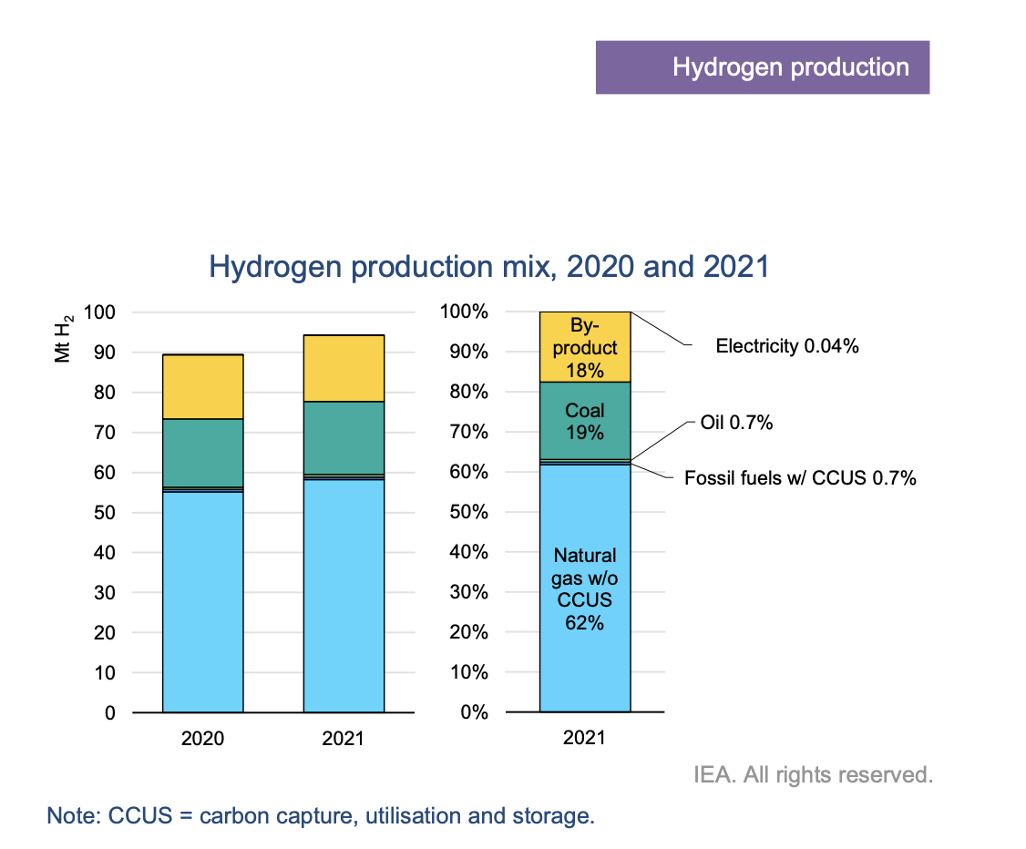

**Bringing down production costs of trending low-emission hydrogen**

In 2021, in most regions the cost of low-emission hydrogen production was more expensive than the fossil fuels without CCUS route. The average cost comparisons are: USD 1.0-2.5/kg H2 from unabated natural gas; USD 1.5-3.0/kg H2 from natural gas with CCUS; and USD 4.0-9.0/kg H2 for production via electrolysis with renewable electricity.

|  |  |  |
| --- | --- | --- |
| 2021 Cost of Low-Emission hydrogen production | Type | Cost (USD) |
| Unabated Natural Gas | $1.0-2.5/kg |
| Natural Gas with CCUS | $1.5-3.0/kg |
| Electrolysis with renewable electricity | $4.0-9.0/kg |
| 2022 Cost of Low-Emission hydrogen production | Unabated Natural Gas | $4.8-7.8/kg |
|  | Natural Gas with CCUS | $5.3-8.6/kg |
| Prediction of 2030 | Electrolysis from solar PV | $1.5/kg |
| Prediction of 2050 (in Good Solar Condition) | Electrolysis from solar PV | $1/kg |

Russia’s invasion of Ukraine in early 2022 has amplified energy security concerns, with physical supply constraints for natural gas in Europe and a surge in natural gas prices over recent months, following a price surge in the second-half of 2021, as demand recovered from the Covid-19 pandemic.

This has changed the economics of producing hydrogen from natural gas, for both with and without CCUS. At prices of USD 25-45 per million British thermal units (MBtu) observed in June 2022 in gas markets in Europe, hydrogen production costs from unabated natural gas at USD 4.8-7.8/kg H2 are up to three-times the levels in 2021. Costs for hydrogen from natural gas with CCUS are in the range of USD 5.3-8.6/kg H2, of which USD 4.1-7.4/kg H2 alone is due to natural gas costs.

With such prices, renewable hydrogen could become the cheapest option for producing hydrogen today in many regions if production capacity was available. It is, however, unclear how long this price situation will prevail. In the longer term, natural gas prices may decline again, improving the competitiveness of hydrogen production from natural gas. By 2030, hydrogen from solar PV could fall below USD 1.5/kg H2 and by 2050 below USD 1/kg H2 in regions with good solar conditions, (i.e. 2 600 full load hours), and thus low costs for electricity from solar PV, which account in these cases for around 55% of the total hydrogen production costs. Solar PV electricity costs have to fall to USD 14/MWh by 2030 and USD 11/MWh by 2050 to reach these hydrogen production cost levels. Alongside cost reductions and efficiency improvements for electrolysers, this would make hydrogen from solar PV by 2030 in regions with good resource conditions competitive with hydrogen production from natural gas with CCUS. The US Hydrogen Earthshot initiative aims to achieve hydrogen costs of USD 1/kg H2 by 2030.

Sources: IEA (International Energy Agency)

4. Storage and Transportation

4.1 Different Methods, pros and cons

**Storage**

Hydrogen can be [stored physically](https://www.energy.gov/eere/fuelcells/physical-hydrogen-storage) as either a gas or a liquid. Storage of hydrogen as a gas typically requires high-pressure tanks (350–700 bar [5,000–10,000 psi] tank pressure). Storage of hydrogen as a liquid requires cryogenic temperatures because the boiling point of hydrogen at one atmosphere pressure is −252.8°C. Hydrogen can also be stored on the surfaces of solids (by adsorption) or within solids (by absorption).

Hydrogen energy storage systems have great market potential and a lot of companies are ready to grab their share of profits.

**Pros:**

Enabling greater incorporation of renewable energy generation;

**Cons:**

High capital cost of the liquid;

Strict government regulations;

Challenges:(<https://www.energy.gov/eere/fuelcells/hydrogen-storage>)

High density hydrogen storage is a challenge for stationary and portable applications and remains a significant challenge for transportation applications. Presently available storage options typically require large-volume systems that store hydrogen in gaseous form. This is less of an issue for stationary applications, where the footprint of compressed gas tanks may be less critical. However, fuel-cell-powered vehicles require enough hydrogen to provide a driving range of more than 300 miles with the ability to quickly and easily refuel the vehicle.

To overcome these challenges HFTO is pursuing two strategic pathways, targeting both near-term and long-term solutions. The long-term pathway focuses on both (1) cold or cryo-compressed hydrogen storage, where increased hydrogen density and insulated pressure vessels may allow for DOE targets to be met and (2) materials-based hydrogen storage technologies, including [sorbents](https://www.energy.gov/eere/fuelcells/sorbent-storage-materials), [chemical hydrogen storage materials](https://www.energy.gov/eere/fuelcells/chemical-hydrogen-storage-materials), and [metal hydrides](https://www.energy.gov/eere/fuelcells/metal-hydride-storage-materials), with properties having potential to meet DOE hydrogen storage targets.

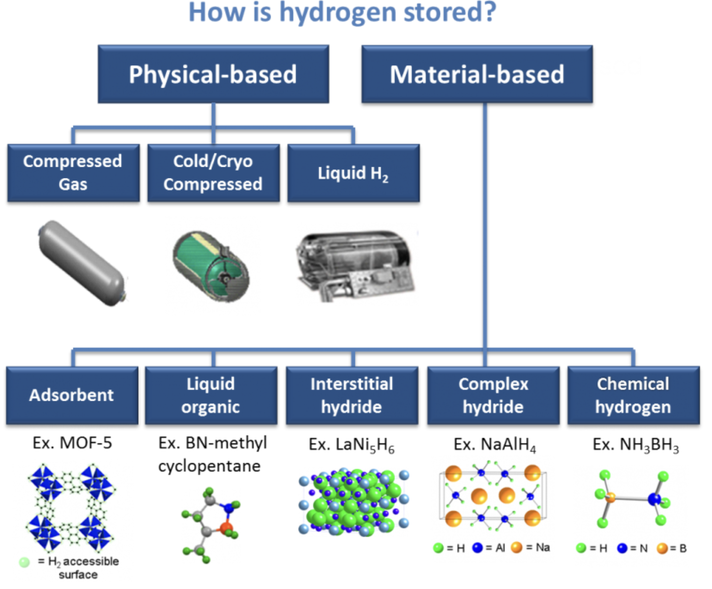

**Transportation**

Can be transported in a variety of forms: Gas, Liquid, Compound, Mechanochemical;

**Gas:** Hydrogen can be transported in gaseous form, typically in a pipeline. Because hydrogen gas is highly reactive, the pipeline or other container must be able to resist interacting with the gas. Hydrogen's low density at atmospheric pressure means that gas transport is suitable only for low volume requirements

**Liquid:** Hydrogen switches to the liquid phase at −253 °C (−423.4 °F). Thus, transporting liquid hydrogen requires sophisticated refrigeration technologies such as cryogenic tanker trucks and liquefaction plants.

**Compound:** Hydrogen can be reacted with other elements to form a variety of compounds. This allows it to be transported in either liquid (e.g., water) or solid form. One variation on this concept is to transport atomic silicon, produced using [renewable energy](https://en.wikipedia.org/wiki/Renewable_energy). Mixing silicon with water separates water's oxygen from its hydrogen without requiring additional energy. The hydrogen can then be oxidizedxx with the oxygen (or air) to produce energy (with water as the only byproduct).

**Mechanochemical:** [Mechanochemistry](https://en.wikipedia.org/wiki/Mechanochemistry) refers to [chemical reactions](https://en.wikipedia.org/wiki/Chemical_reaction_model) triggered by mechanical forces as opposed to heat, light, or electric potential. [Ball milling](https://en.wikipedia.org/wiki/Ball_mill) can crush material such as [boron nitride](https://en.wikipedia.org/wiki/Boron_nitride) or [graphene](https://en.wikipedia.org/wiki/Graphene), allowing hydrogen gas to be absorbed by the powder, storing the hydrogen. The hydrogen can be released by heating the powder. These techniques offer the potential of substantial net energy savings

**4.2 Investment Opportunities**

<https://finance.yahoo.com/news/hydrogen-energy-storage-market-hit-010000837.html>

Major hydrogen energy storage market participants include Air Liquide, Air Products and Chemicals, Inc., Nel ASA, McPhy Energy S.A., Linde plc, ENGIE, ITM Power PLC, FuelCell Energy, Inc., GKN Hydrogen, Gravitricity Ltd, SSE, HYDROGEN IN MOTION, and Cockerill Jingli Hydrogen.

Selbyville, Delaware, May 29, 2023 (GLOBE NEWSWIRE) –

The Hydrogen Energy Storage Market is expected to cross a valuation of USD 17.6 billion by 2032 according to the [recent research report](https://www.globenewswire.com/Tracker?data=gwCvbHg3dC_rpDHf-7AaEJ6sPqHAIyag_TaMMEVsw7-R0R8wr1XZlKFv7XORtbjNLrH_9ZEZwXiCXhHYij6-p6Cw6c8EPxwhUDlvTKrPm9eieanldi9GSbU-BtjoWZqassXFSt_tswzn5QRY8i9jMMCN4QP4RMAxiIuqVlJzvm9iBhAz7lC0sqdl4HMf93ELhlO4oxbTlWsNxjt_J7siyiue4f7dSeQoyakFJ0caeY5jIr50KsymHIIGUbFsOTZlgHzMfkYWrRmsP7qpN0qCRw==) by Global Market Insights Inc.

**Rising investments in liquid hydrogen storage systems**

Hydrogen energy storage market share from the liquid segment was more than 14% in 2022. Liquid hydrogen is one of the cleanest energy sources currently available as it only emits water vapor when burned. The public and corporate sectors have both increased their investments to support the use of liquid hydrogen as a form of energy storage. The rising investments are expected to create new opportunities for the development of liquid-state hydrogen storage.

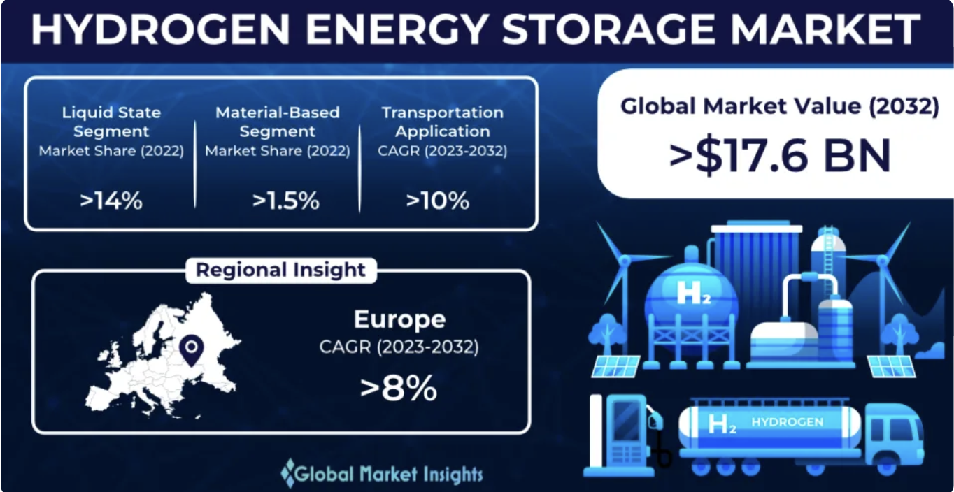

# 5. Utilization

5.1 Different end uses: industry, transport, buildings, power generation

Hydrogen can be seen as an energy carrier, like electricity, but also serves as a critical feedstock in multiple industries.

**Uses of Hydrogen: Fuel Vs. Chemical Applications**

**Fuel:**

* Fuel Cells
* Engines/Turbines
* Energy Storage

**Chemical:**

* Petroleum Recovery & Refining
* Methanol Production
* Electronics
* Ammonia Production
* Metal Production & Fabrication
* Food Processing
* Cosmetics

**Hydrogen Consumption in the US by End Market (2021)**

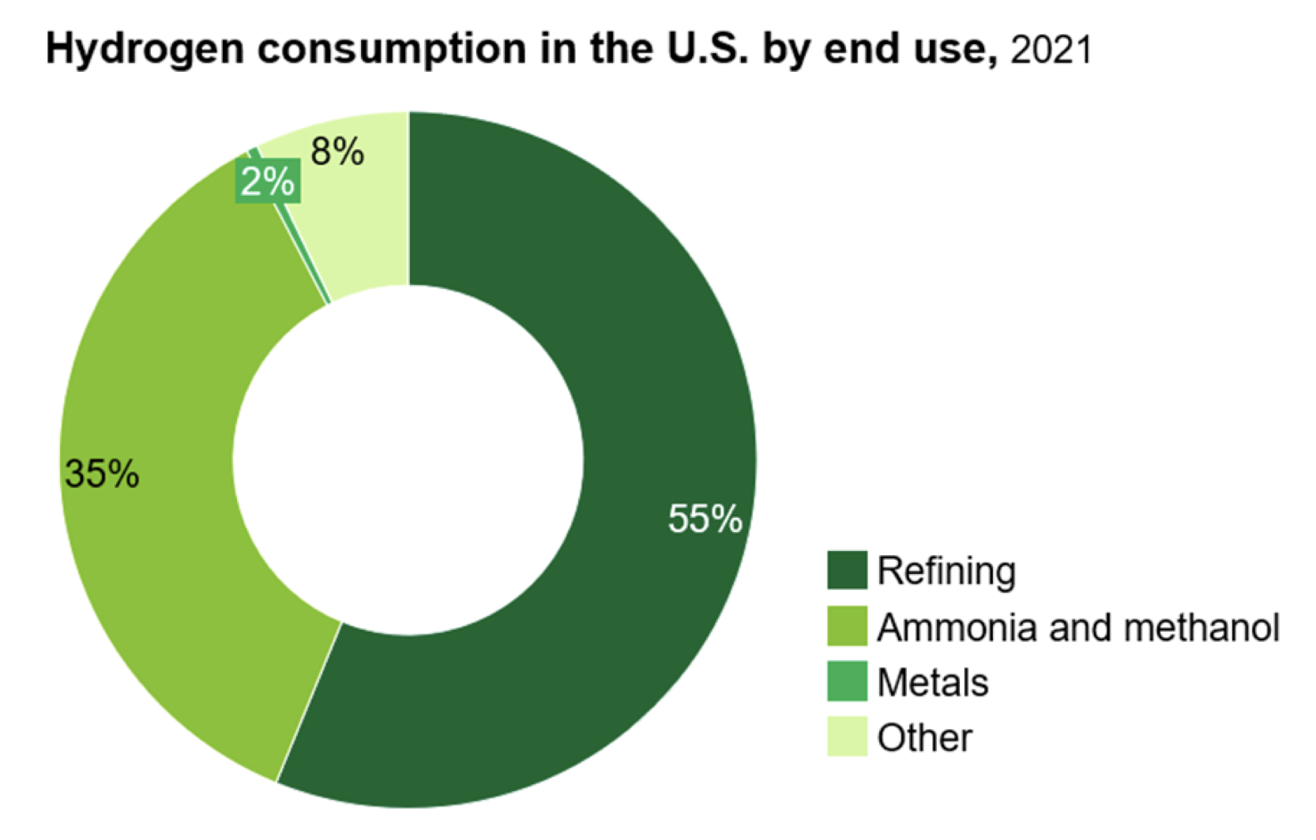

**Uses of Hydrogen by Sectors: from Short-term to Long-term** (Source: the [Landscape](https://industrialinnovation.org/wp-content/uploads/2023/05/The-Landscape-of-Clean-Hydrogen.pdf) of Clean Hydrogen, CS & I3)

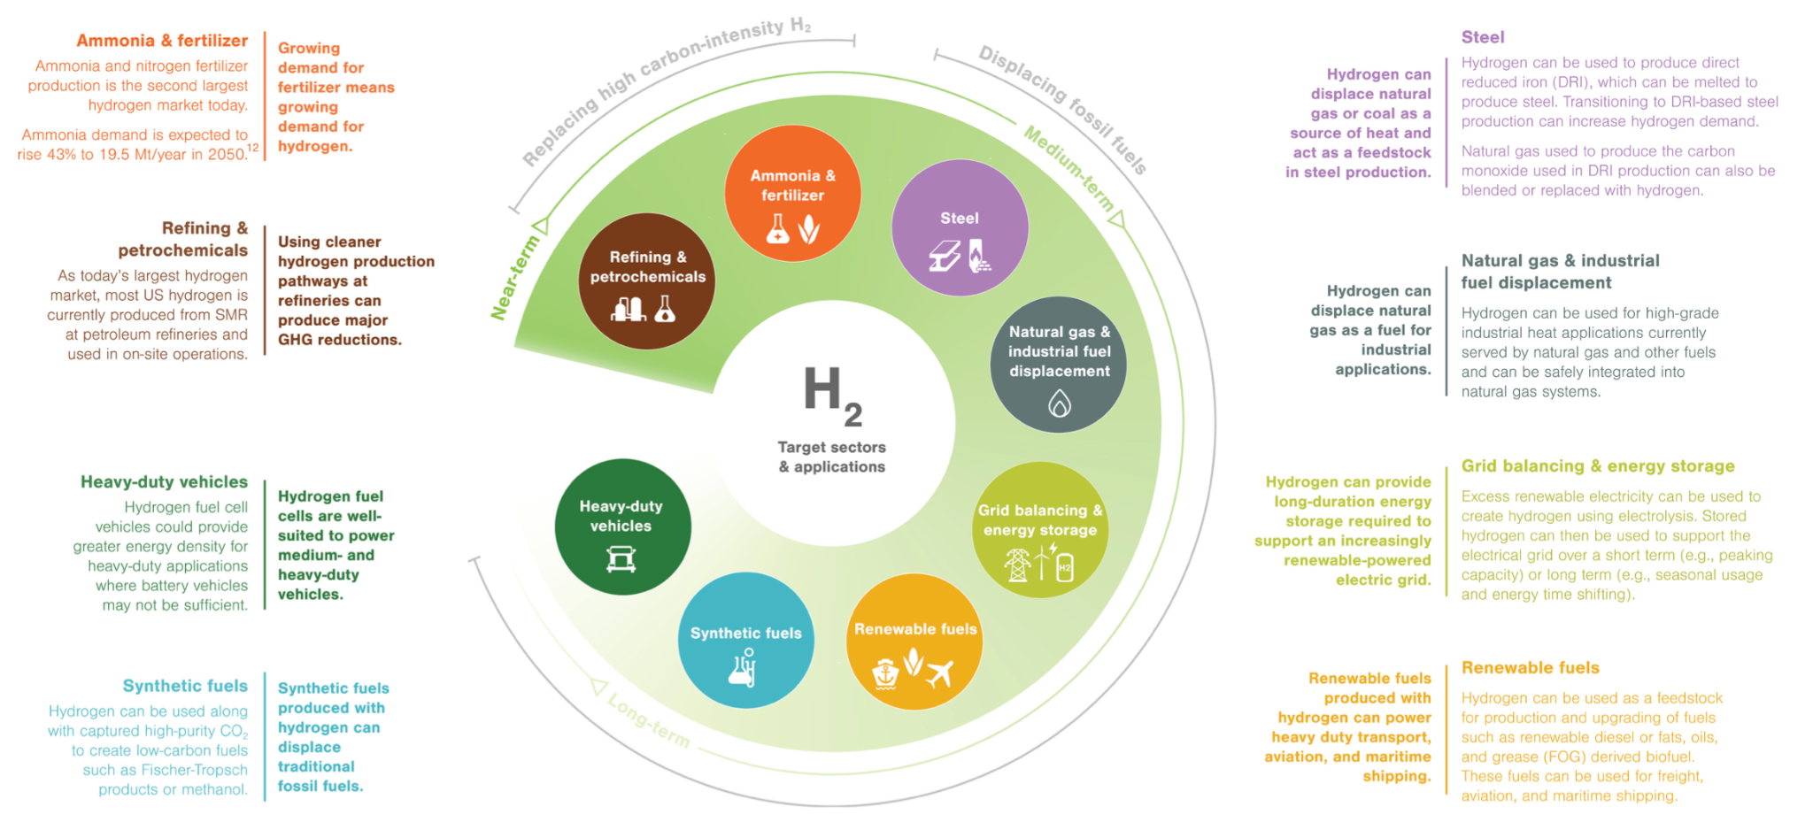

# 6. Investment Opportunities

6.1 Key investment opportunities within hydrogen sector

Key Players, PE VC investment trend, M&A deals, Developer (Initial investment, time, tax equity)

Loan Market, Credit market, Bank Strategy.

**Key Players:**

Air Products:

Air Products is one of the world leaders in supplying industrial gases. It's a global leader in [liquefied natural gas](https://www.fool.com/investing/stock-market/market-sectors/energy/liquefied-natural-gas-stocks/) (LNG) processing technology and equipment. It's also one of the world's largest suppliers of merchant hydrogen and a leader in hydrogen fuel infrastructure. It has more than 100 hydrogen plants with the capacity to produce 7 million kilograms of the fuel each day.

Air Products aspires to be a leader in providing solutions to the world's [energy and environmental challenges](https://www.fool.com/investing/stock-market/types-of-stocks/esg-investing/esg-stocks/) through gasification, carbon capture, and clean hydrogen. It has several major hydrogen projects underway that it expects to complete in the coming years. Its $7 billion carbon-free hydrogen joint venture in Saudi Arabia is the biggest. The project would use renewable energy to produce 650 tons per day when completed in 2025. The project and others under development position Air Products to remain a leading global hydrogen energy company.

BP is a global [oil and gas](https://www.fool.com/investing/stock-market/market-sectors/energy/oil-stocks/are-oil-gas-good-investment/) producer with grand lower-carbon energy ambitions. It set a goal to be a net-zero company by 2050 or earlier.

Hydrogen is a crucial aspect of its strategy. BP intends to capture a 10% share of the hydrogen market in its core operating areas. That's driving it to advance hydrogen projects across the U.K., Europe, the U.S., and Australia.

For example, in the U.K., it's developing plans to build that country's largest blue hydrogen production plant (H2Tesside). It's also developing HyGreen Tesside, a large-scale green hydrogen production facility. The projects could deliver 15% of the U.K.'s 2030 target for low-carbon hydrogen production.

[Plug Power](https://www.fool.com/investing/how-to-invest/stocks/how-to-invest-in-plug-stock/) is a pioneer in the hydrogen fuel cell industry. It created the first commercially viable market for hydrogen fuel cell technology. It has deployed an industry-leading 60,000 fuel cell systems for the e-mobility market (using [electric powertrain technologies](https://www.fool.com/investing/stock-market/market-sectors/consumer-discretionary/automotive-stocks/electric-vehicle-etfs/) to power vehicles and fleets). It's one of the world's largest hydrogen buyers and operates a leading hydrogen refueling network in North America with more than 180 fueling stations.

Plug Power is building an end-to-end green hydrogen network to produce, store, and deliver the fuel across North America and Europe. It expects to produce 2,000 tons of green hydrogen per day by 2030. The company's strategy of building the world's first green hydrogen ecosystem positions Plug Power as a potential category leader in this massive market opportunity.

Bloom Energy's mission is to make clean, reliable, and affordable energy. The company has developed the Bloom Energy Server, an electric power generation platform. It also created the Bloom Electrolyzer, using the same solid oxide technology as its Bloom Energy Server. The product can produce clean hydrogen 15% to 45% more efficiently than others on the market.

Bloom Energy believes the Bloom Electrolyzer is a major leap forward for hydrogen. It hopes the technology will enable heavy industries such as steel, chemicals, cement, and glass manufacturing to decarbonize. Bloom Energy can pair its Bloom Electrolyzer with solar energy and wind energy to generate green hydrogen, which it can store and eventually turn back into electricity for future use.

Hydrogen Facility Investment.

https://www.theguardian.com/world/2021/may/27/oman-plans-to-build-worlds-largest-green-hydrogen-plant

**6.2 Investment trends**

1. Companies are hesitant to invest in Hydrogen and other renewable energy due to the raise in interest rates. Borrowing cost is too high.
2. Federal investments

On October 13, 2023, President Joe Biden and U.S. Secretary of Energy Jennifer Granholm announced the seven projects selected for funding through the H2Hubs program:

Appalachian Regional Clean Hydrogen Hub (ARCH2)

Also referred to as Appalachian Hydrogen Hub

State participants: Kentucky, Pennsylvania, Ohio, West Virginia

Hydrogen production type: Blue, produced through natural gas with permanent carbon storage

Federal cost share: $925 million

Alliance for Renewable Clean Hydrogen Energy Systems (ARCHES)

Also referred to as California Hydrogen Hub

State participant: California

Hydrogen production type: Green, produced through renewable energy and biomass sources

Federal cost share: $1.2 billion

HyVelocity H2Hub

Also referred to as Gulf Coast Hydrogen Hub

State participant: Texas

Hydrogen production type: Blue & Green, produced through natural gas with permanent carbon storage and through renewable energy

Federal cost share: $1.2 billion

Heartland Hydrogen Hub (HH2H)

State participants: Minnesota, Montana, North Dakota, Wisconsin

Hydrogen production type: Blue & Green, produced through natural gas with permanent carbon storage and through renewable energy

Federal cost share: $925 million

Mid-Atlantic Clean Hydrogen Hub (MACH2)

State participants: Delaware, New Jersey, Pennsylvania

Hydrogen production type: Green & Pink, produced through renewable energy and nuclear energy

Federal cost share: $750 million

Midwest Alliance for Clean Hydrogen (MachH2)

State participants: Illinois, Indiana, Michigan

Hydrogen production type: Blue, Green, & Pink, produced through natural gas with permanent carbon storage, renewable energy, and nuclear energy

Federal cost share: $1 billion

Pacific Northwest Hydrogen Hub (PNW H2)

State participants: Montana, Oregon, Washington

Hydrogen production type: Green, produced through renewable energy

Federal cost share: $1 billion

6.3: M&A Trends

Analysis of the key themes driving M&A activity reveals that hydrogen accounted for 11 power deals announced in Q3 2023, worth a total value of $2.6bn. The $2.4bn minority acquisition of Avaada Energy by REC was the industry’s largest disclosed deal. GlobalData’s Power Industry Mergers and Acquisitions Deals report for Q3 2023 uncovers key trends behind the power market M&A deals and helps gain a comprehensive understanding of the disruptive themes driving most notable deals.

In value terms, hydrogen-related deal activity decreased by 24% in Q3 2023 compared with the previous quarter’s total of $3.4bn and rose by 46% as compared to Q3 2022. Related deal volume decreased by 21% in Q3 2023 versus the previous quarter and was 42% lower than in Q3 2022.

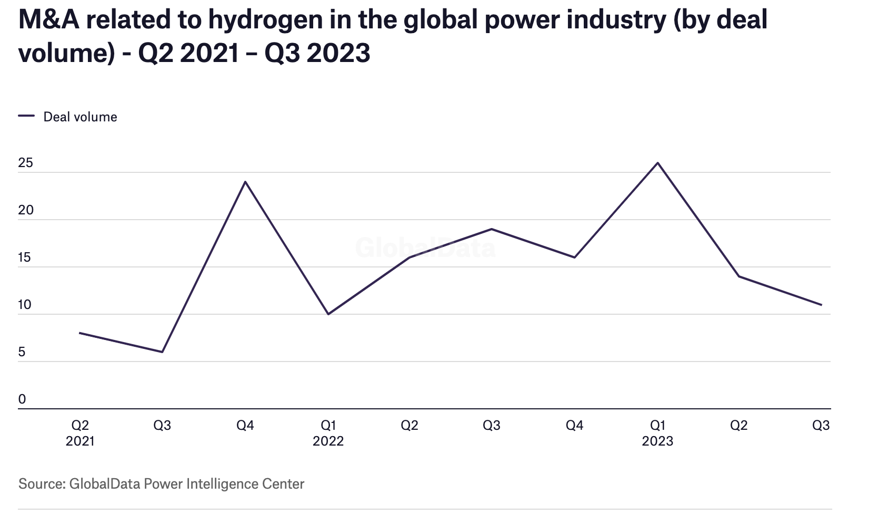

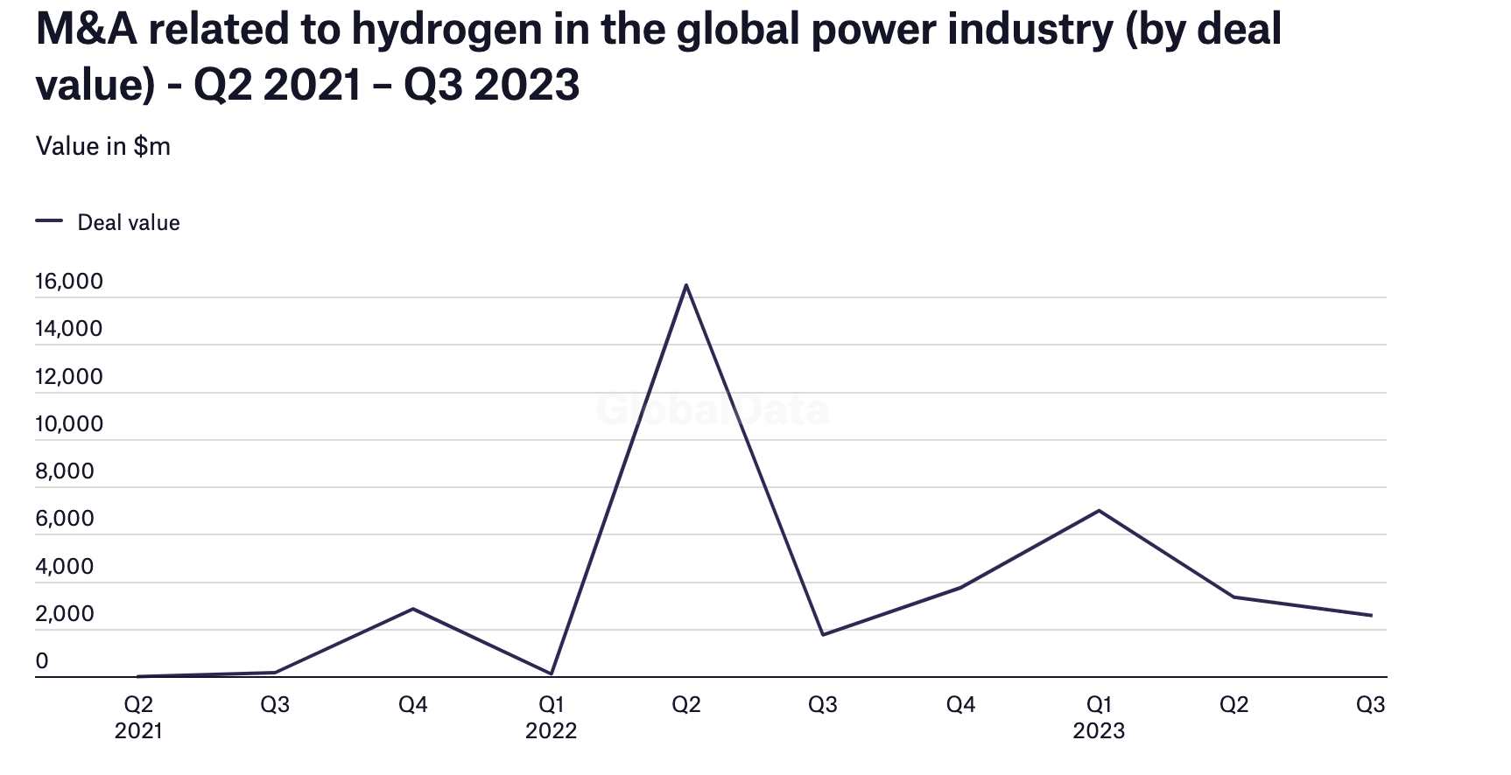

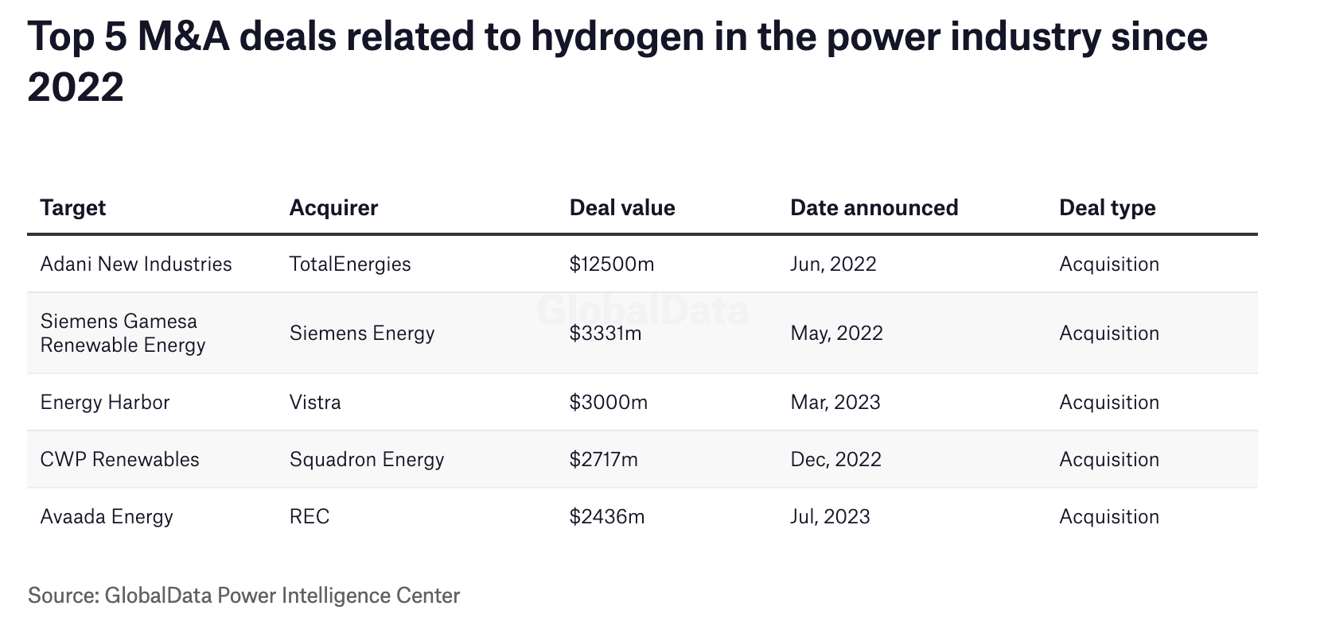

Deal synergy and Deal structure, Rationale behind these transactions.

Siemens Energy and Siemens Gamesa Renewable Energy

Deal Value :$3.3 Billion Projects target a total investment of approximately EUR 120 million over five years in developments leading to a fully integrated offshore wind-to-hydrogen solution

- Projects are first major step to develop an industrial-scale system capable of harvesting green

hydrogen from offshore wind

- Developments will enable decarbonization of hard-to-abate sectors such as transport and

heavy industry

- Implementation within the framework of the ideas competition "Hydrogen Republic of

Germany" of the Federal Ministry of Education and Research

The ultimate fully integrated offshore wind-to-hydrogen solution will produce green hydrogen using an electrolyzer array located at the base of the offshore wind turbine tower, blazing a trail towards offshore hydrogen production. The solution will lower the cost of hydrogen by being able to run off grid, opening up more and better wind sites.

**Summarization of Opportunity and Trends:**

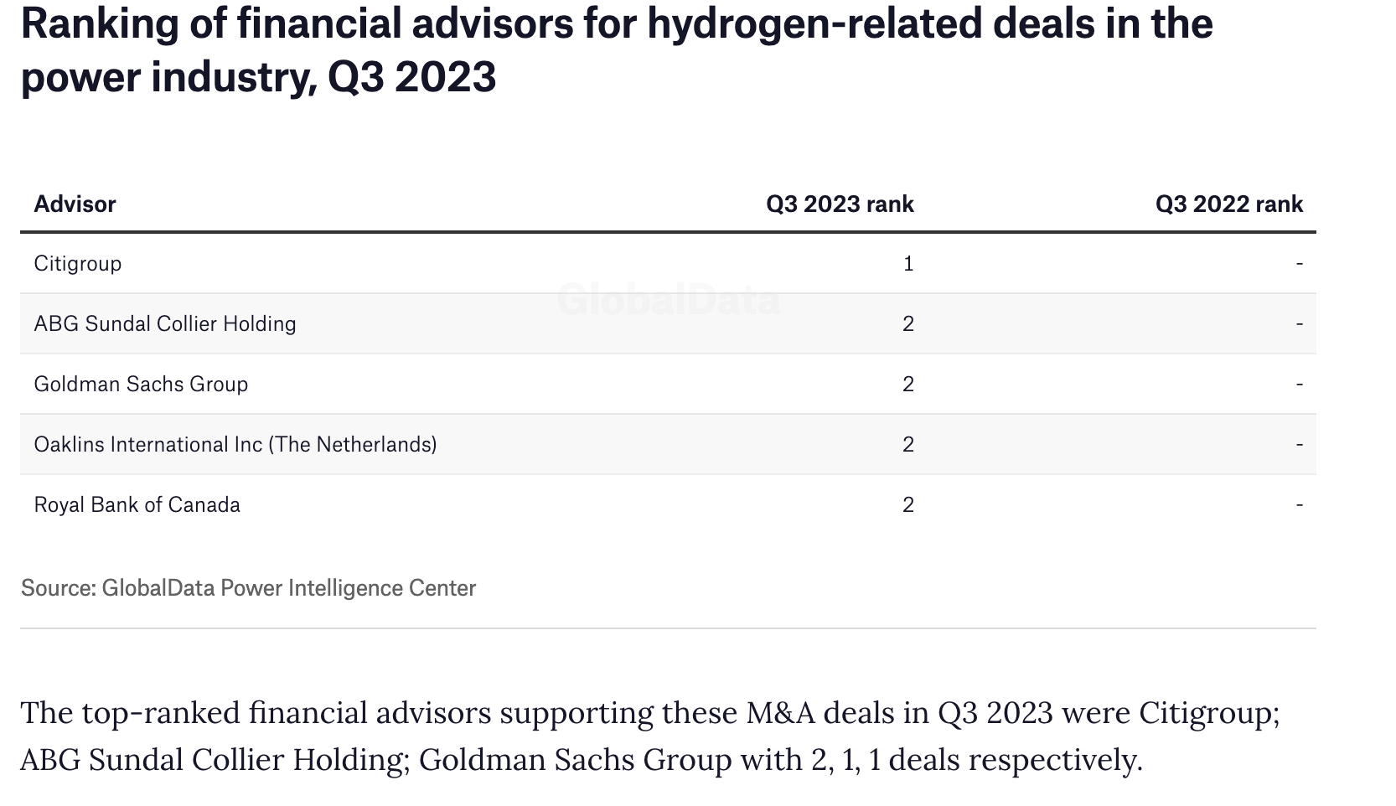

# 7. Risk Assessment

**A. Hydrogen Pipeline Overview**

Currently, almost all of the hydrogen pipelines in the United States are in specialized hydrogen infrastructure owned by hydrogen producers. More than 90% of these pipelines are located along the Gulf of Mexico in Texas, Louisiana, and Alabama. The requirements for Hydrogen Vehicle Corridors (HVD) include the condition that the distance between public hydrogen stations on the corridor should not exceed 100 miles. Due to a delay in hydrogen station construction, apart from several completed hydrogen corridors in California, the planned hydrogen corridors in other states in the U.S. are currently in a pending status. The construction of hydrogen corridors is still in its early stages.

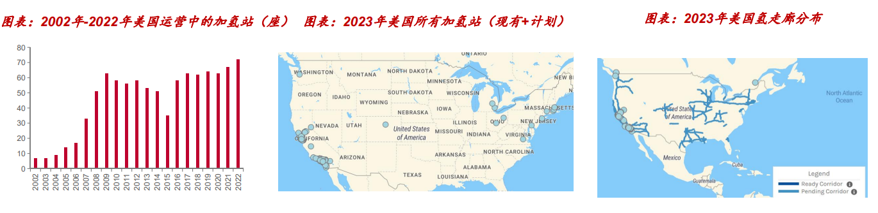

**B. Downstream Sales:**

As of the end of 2022, the total number of hydrogen fuel vehicles in the U.S. is close to 15,000. The annual sales of hydrogen fuel vehicles in 2022 were 2,707, a **19% decrease compared to the previous yea**r. Among them, Toyota Mirai sales were 2,094, a 20% decrease, Hyundai Nexo sales were 408, a 5% decrease, and sales of other models were 205, a 27% decrease. Limited by factors such as car prices, overall energy efficiency, refueling infrastructure, and the number of models, fuel cell vehicle sales in the U.S. are mainly concentrated in California. However, the total number of fuel cell vehicles is on the rise. Therefore, from the downstream sales perspective, there is not a strong willingness from automakers to promote and sell hydrogen-powered vehicles, which will further impact the return on investment and the cycle of the hydrogen energy industry.

**C. Hydrogen Storage Technology Bottleneck：**

The development of hydrogen energy technology and storage and transportation facilities in the U.S. has made progress, but there are still bottlenecks on the storage and transportation side of hydrogen energy. The U.S. has advanced liquid and solid hydrogen storage and transportation technology facilities, with NASA owning the world's two largest liquid hydrogen tanks. The U.S. also utilizes salt caverns, abandoned oil and gas fields for hydrogen storage, constructs hydrogen pipelines, and gives natural gas pipelines the capability to transport hydrogen. However, there is a significant gap in the efficiency, cost, and safety of hydrogen storage and distribution compared to market demand. Due to the limited or remote hydrogen stations, U.S. car owners face challenges in refueling, and fuel cell vehicles are priced higher than electric vehicles in the same category. The majority of the 56 hydrogen stations in the U.S. are located in California, and the scale is limited.

# 8. Financing Methods

The main valuation technique of a hydrogen company is to see how much energy the machine can generate. Usually Power producers use what’s called a PPA (Power Purchase Agreement) to sell energy to consumers or to the grid. This is heavily affected by the volatile nature of recent interest rate and many IPP (independent power producers) who signed a PPA prior to the pandemic, will need to either halt their project, or renegotiate the PPA to generate profit.

However there are three main ways to generate capital for a startup in hydrogen.

1. Green Bonds
   1. The proceeds from green bonds are used to fund projects that have positive environmental impacts, such as renewable energy projects (wind, solar, hydroelectric), energy efficiency upgrades, sustainable waste management, clean transportation, sustainable water management, biodiversity conservation, and pollution prevention.
   2. Issuers of green bonds typically provide transparency about how the funds are being used. This often includes detailed reporting on the environmental impacts of the projects financed by the bonds.
   3. The green bond market has grown rapidly in recent years as more investors seek environmentally friendly investment options and as awareness of climate change increases.
2. Project Finance
   1. Project Finance is a mixture between equity raising and debt financing. The structuring of each project is different based on the types of renewable energy it is generating. For Hydrogen, it is very similar to financing LNG projects. Project financing is affected by the rise of interest rates which makes debt financing much more difficult which in term increases the percentage of equity financing in a project. As equity increases the whole project IRR lowers and negatively affects profitability of the project.
3. Tax Equity
   1. The IRA has given the implementation of ITC, PTC and additional bonus tax credits for certain renewable energy projects. For hydrogen projects, $3 per kg of hydrogen produced to projects with low lifecycle greenhouse gas emissions intensity is awarded.
   2. The IRS is constantly giving out additional guidance on the Tax Equity front which will focus on pushing renewable energy forward.
   3. To better understand what the Section 45V Hydrogen Production Tax Credit entails, it’s important to gain clarity about what is being discussed when the term “qualified clean hydrogen” is used. First, the use of “qualified clean hydrogen” refers to a project that produces greenhouse gas emissions not exceeding 4kg of CO2 per kg of hydrogen, and the corresponding tax credits are then organized in four tiers, which reward a greater tax credit to those who produce a considerably cleaner form of hydrogen.

The first tier provides a 20% applicable percentage when the emissions rate ranges from 4kg to 2.5kg of CO2 per kg of hydrogen.

The second tier provides 25%, with emissions ranging from 2.5kg to 1.5kg of CO2 per kg of hydrogen.

The third tier provides a 33.4% applicable percentage when the emissions rate ranges from 1.5kg to 0.45kg of CO2 per kg of hydrogen.

* 1. Finally, the largest applicable percentage is 100%, which is when the emissions rate is less than 0.45kg of CO2 per kg of hydrogen.

These are the three key components of a hydrogen energy project valuation however one key thing to consider is that there is currently a lack of infrastructure to transport or store electricity made by hydro power in the US. Which is another key investment trend that companies can focus on.

# 9. Key Findings

* In summary, the hydrogen energy industry works more like the start-up space with major players focusing more on investing potential technology breakthroughs. Infrastructure is a key investment trend in the US to transmit Green Hydrogen energy however it is slowed by the rise of interest rates like many other project based industries. For example Real Estate.
* The industry is also closely related to the amount of renewable energy being produced such as solar, wind, and geothermal and etc. The market is expected to reach 10% of overall energy production in the USA in the future.
* The green hydrogen supply chain is expected to experience significant growth and increasing demand in the near future.
* In the United States, policy incentives for the hydrogen supply chain primarily revolves around two pieces of legislation: the Bipartisan Infrastructure Law (BIL) and the Inflation Reduction Act (IRA).

**10. References**

<https://www.hydro.org/powerhouse/article/how-the-hydrogen-production-tax-credit-can-help-hydropower/#:~:text=This%20tax%20credit%20awards%20up,hydrogen%20into%20their%20energy%20portfolios>.

https://assets.kpmg.com/content/dam/kpmg/cn/pdf/en/2022/09/understand-the-hydrogen-energy-industry-in-one-article.pdf